**Merging Current/Feature Branch to Develop/Master Branch**

* **Stay on current branch**

* **Commit changes with message from VS** **code : US72042-feature-CourseDate-msg**

* **Push** **Command : git push origin "current branch name"**
* **Eg : git push origin feature/US72042-CourseDate**
* **Click on the PR Link in terminal**
* **Select Branch where to push the changes in the PR Link**

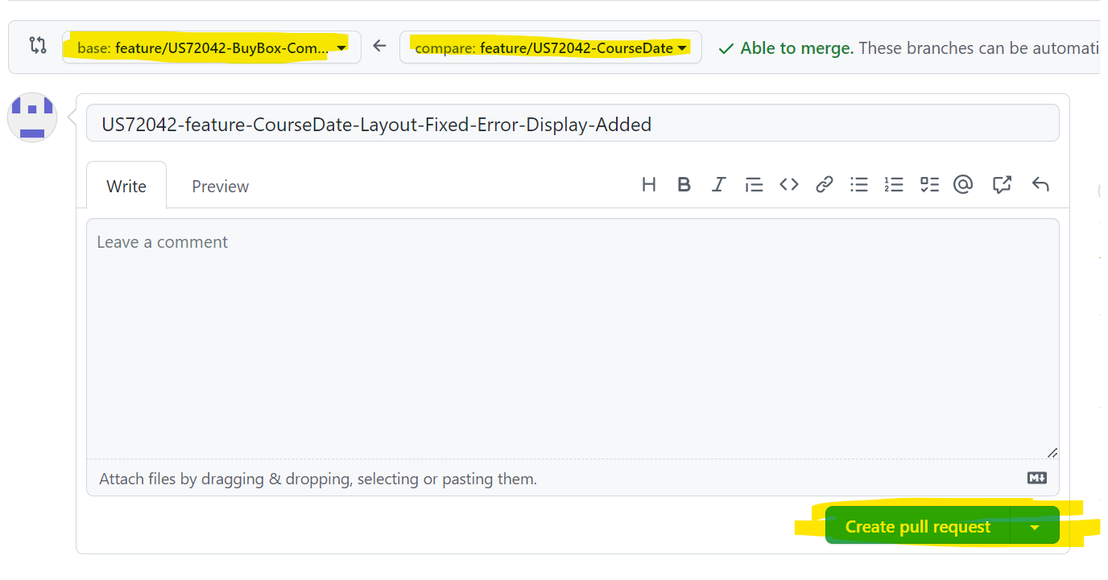

**Select Create Pull Request**

**-----------------------------------**

**Pulling from** **origin** : **git pull origin feature/US72042-BuyBox-Component**

**-----------------------------------**

**Copying Other Dev Branch**

**git fetch or git fetch --all**

**git checkout branchnamewhichshouldbecopied**

**GIT** **STASH**

**git** **stash**  - to switch branch with current changes in file.

**git** **stash -u** - to switch branch with adding untracked files as well.

**git stash pop** - to get your stashed changes back.

**git stash list** - to get all stash changes.

**git stash clear** - to clear all stash.

**git stash push -m "Message"** - to save changes with name.

**git** **stash apply "stash****@{0}"** - To apply specific indexed Stash from Stash List

**git stash drop "stash****@{1}"** - delete specific

**DELETE** **BRANCH**

git branch --delete feature/DE59648-UX-issue or git branch --D feature/DE59648-UX-issue

**DELETE LAST ACCIDENTAL COMMIT FROM A DRAFTED/FEATURE BRANCH**

git log

git reset --hard "Last Wrong Commit ID"

Eg : git reset --hard 15cdea1755c74cf253476c12730a3877a1036759

git reset --hard HEAD~1

git push origin HEAD --force

**Release Line PR**

Release Link : <https://gehealthcare.ent.box.com/folder/296793503368>

**git fetch --all** - in current branch (here : feature/DE60238-FAQ-Css-Fix)

**git checkout release/1.0.****0**  - check the latest release version from git and checkout to that release branch in local or create branch with that

**git pull origin release/1.0.0**

**git checkout -b feature/NewBranchName-****release**  - add release suffix to the new branch name

Eg : git checkout -b feature/DE60238-FAQ-Css-Fix-release

**git cherry-pick** e8bf93aa7e488d5b9cdc234df098053eeb6bfea6 - go to the previous/old/Dev's PR > Commits > Copy the SHA key

Need to do multiple cherry pick if there's multiple commits

Single Cherry Pick

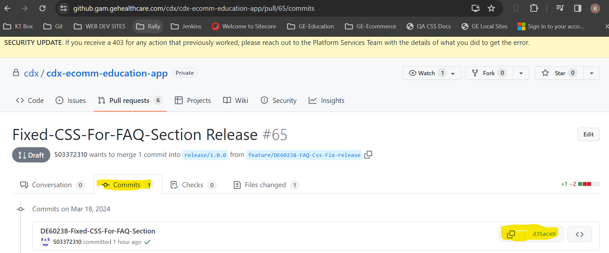

Multiple Cherry Pick for Multiple Commits

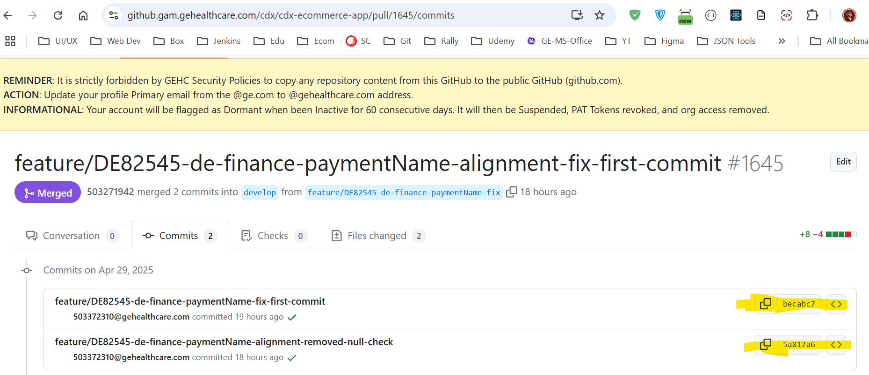

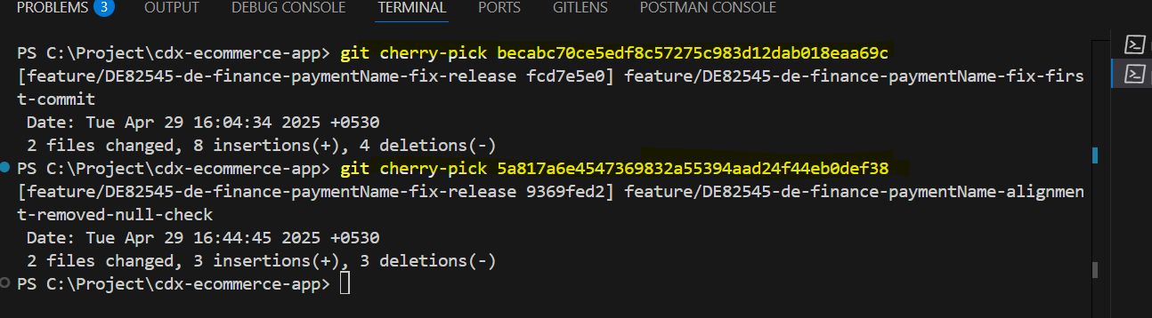

Mutli Cherry Pick with Not required Commits, Ignore the unwanted commits

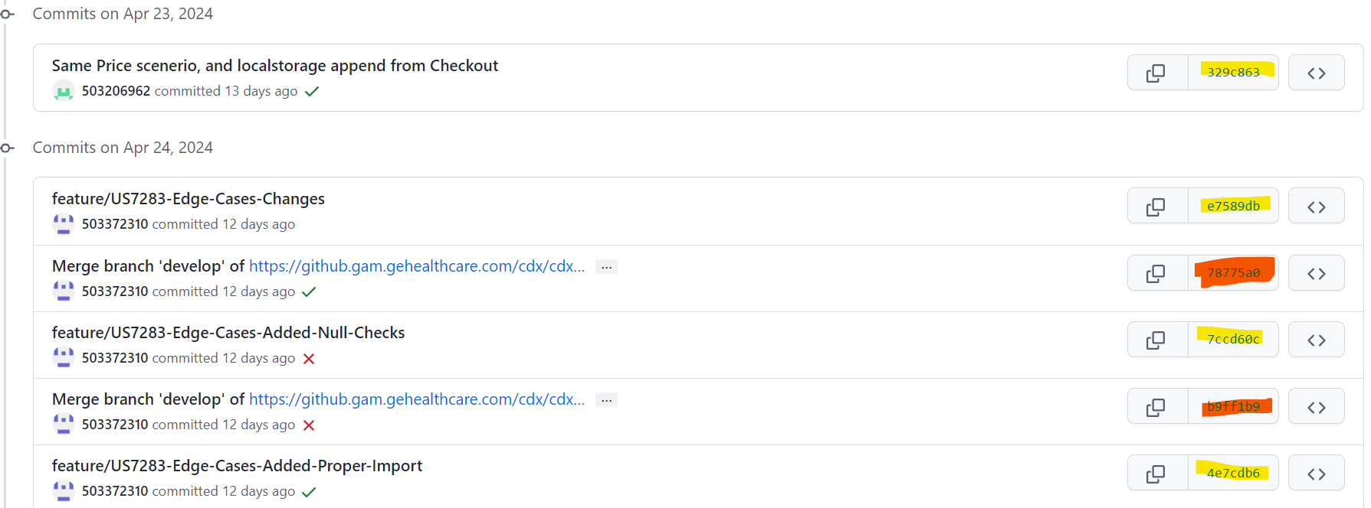

Skip Merge branch develop of commits

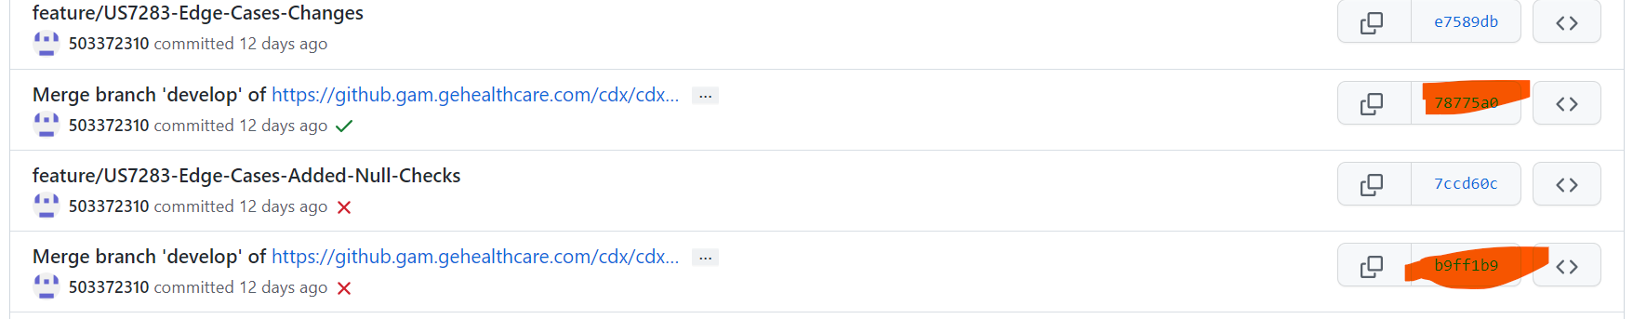

After Cherry Pick Push the Branch

**git push origin feature/CurrentNewBranchName-release**

Eg : git push origin feature/DE60238-FAQ-Css-Fix-release

**Errors/Warning might show up sometime**

Do git pull origin with current release branch name and git push origin current release branch name

And also push the changes from VS code

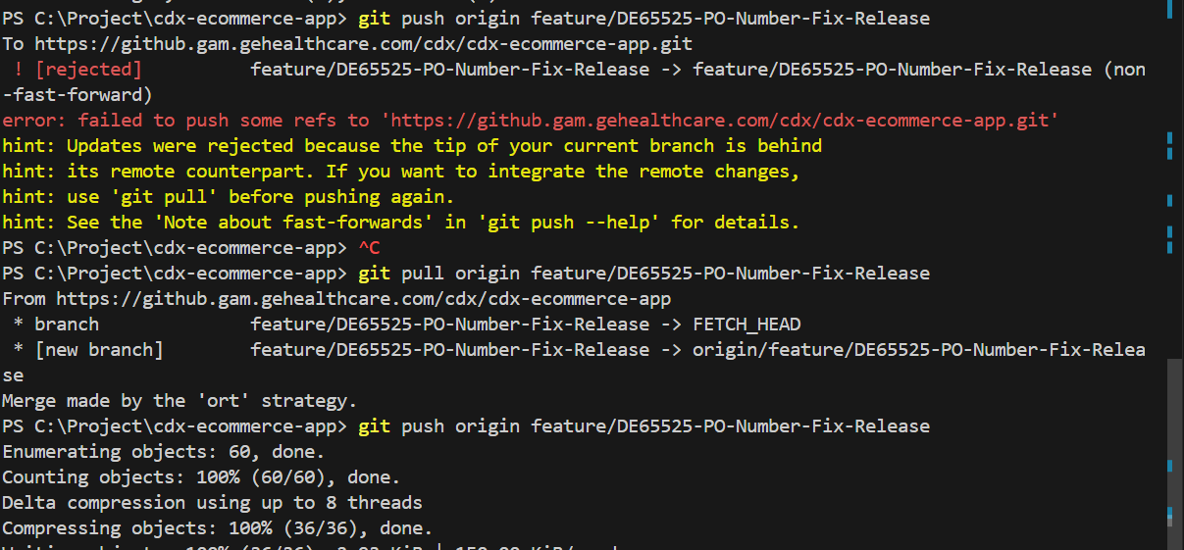

Click on Cloud Push Button

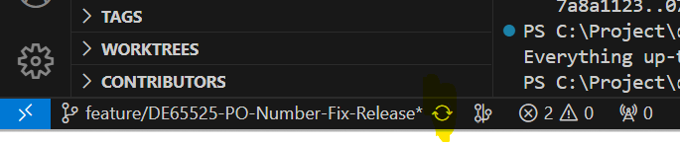

Go to PR and change base branch to latest release version.

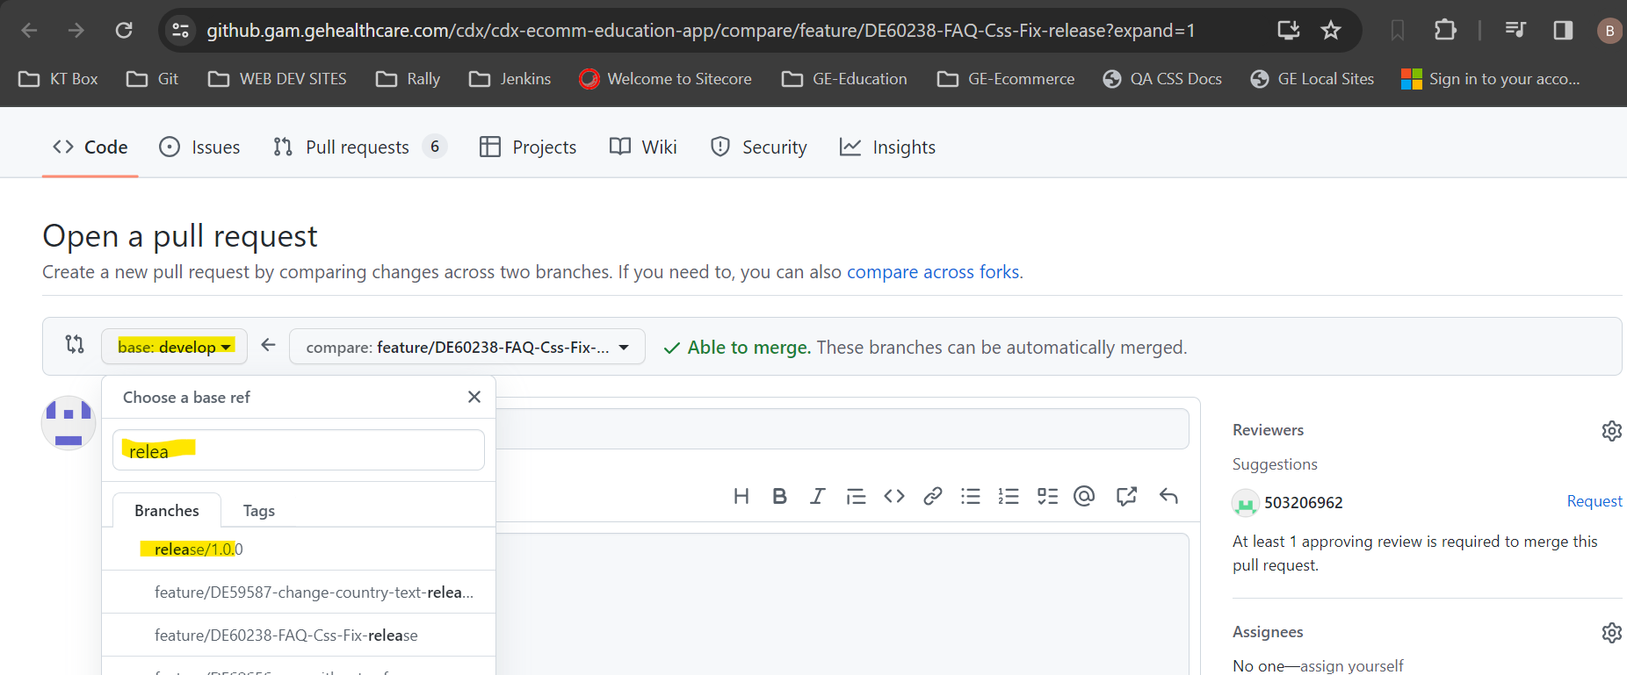

If PR is not shown , change the base and compare branches manually and create PR

Get it merged only

It will get auto deployed and after deployment update it in confluence's deployment table

**Integration PR**

**git pull origin develop in current branch**

**Git** **checkout develop**

**Git pull in** **develop branch**

git checkout integrationbranch/develop_from_cartIntegrationbranch_Education_checkoutFlow

git checkout -b feature/US72840-Payment-Tab-Selections origin/integrationbranch/develop_from_cartIntegrationbranch_Education_checkoutFlow

git push origin feature/US72840-Payment-Tab-Selections

**FE Build Deployment**

**Checkout to Latest / Feature Branch**

**Pull Latest Code of that branch**

**Create Branch name with** **build :** git checkout -b feature/checkout-app-develop-buildv4

**Modify sites.js file with new Content**

Stage the changes

Commit The changes

git push

If you get error, copy the code from CMD and try to push it again

git push --set-upstream origin feature/checkout-app-develop-buildv4

No need to merge the PR or do anything

git merge feature/checkout-app-develop

git push

npm run build

After Build Complete, Find in Whole Project and rename it to

#{RoutePath} to newcheckout

Upload the build : <https://gehealthcare.ent.box.com/folder/283505723832>